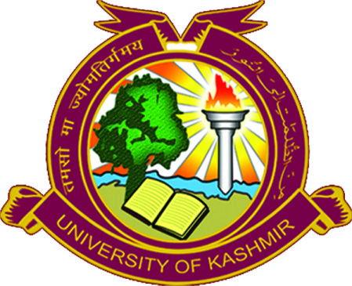
Department of Management Studies
NAAC Accredited Grade “A++”
University of Kashmir, Srinagar
Hazratbal, Srinagar, Kashmir, J&K, India-190006

NOTICE

It is notified for the information of all those candidates who have applied in response to admission notification No.F(Ph.DAdm)RES/KU/23 dated 17/05/2023 for admission to Ph.D programme in Management and are exempted from entrance test on the basis of UGC NET/JRF/SET/M.Phil/ Teacher Fellowship or any other equivalent test declared so by UGC, to appear for interaction with the Departmental Research Committee scheduled to be held on 17-08-2023 at 11.30 a.m in the Department of Management Studies. The candidates should bring alongwith them hardcopy of already downloaded application form and other testimonials in original/photocopy for scrutiny/verification purpose of the same.

Further candidates from outside valley can interact with DRC through offline/ online mode (meet.google.com/wxz-wowt-xpd).

For any clarification contact Research Coordinator on (7006829915).

-sd-
Head of the Department

No: F(Admission/Ph.D)DMS/KU/23
Dated: 09/08/2023

