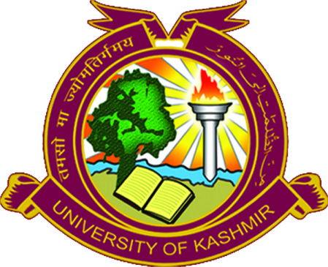
Department of Management Studies
University of Kashmir
(NAAC Accredited Grade A+)
Hazratbal, Srinagar-190006
Ph.0194-2415554, Fax-0194-2415129
www.tbs.uok.edu.in, www.kashmiruniversity.net

NOTICE

The Department of Management Studies, University of Kashmir in collaboration with Rooman Technologies, Bangalore is organising a two day Webinar on Digital Marketing. The Webinar shall provide:

- Understanding various aspects in digital marketing such as importance of website building & optimization, developing the content, use of social media marketing, paid advertising, conversion and nurturing leads, Analytics
- Freelancing career in Digital marketing
- Blogging as career
- Helping startups to grow their business as Digital marketing Consultant
- A glimpse on how to money from online/Affiliate Marketing
- Various Digital Marketing Tools & their importance.

The webinar has been scheduled on 20th Nov 2021 to 21th. Nov 2021, from 2pm to 4pm. All the students of the Department are directed to attend the webinar. Students can register on: https://rooman.net/sri-digital-marketing-workshop/

-sd-
Head of the Department
No: F(two days webinar)BS/KU/16
Dated: 18.11.2021

