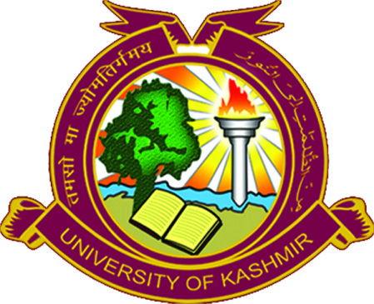
Department of Management Studies
University of Kashmir
Hazratbal, Srinagar-190006
Ph.0194-2415554, Fax-0194-2415129
www.tbs.uok.edu.in, www.kashmiruniversity.net

Notice

It is notified for the information of all girl students of MBA 2nd semester, MBAFM 2nd semester and IMBA 7th semester that Internship programme is being organised at IIM Rohtak from June 10, 2022 to July 10, 2022. All the girl students who are interested to attend the internship program are directed to register themselves on the following link https://docs.google.com/forms/d/e/1FAIpQLSevmI0kKiaI3q86iRsxzw7if6mkuHDpPY8NosYxm-DDkr1Fzg/viewform?usp=sf_link upto 05.06.2022 and produce a written copy of their parental consent by or before 05.06.2022 (1:00 pm).

-sd-
Head of the Department

No:F (Internship)DMS/KU/22
Dated: 02.06.2022

